Task 6
Sub Query

Aim
To study and implement SQL Subqueries using SELECT, INSERT, UPDATE, and DELETE statements on relational tables.

Sub Query
A SQL subquery as the term suggested is a query nested within another query.
These subqueries can be present in the FROM clause, WHERE clause, or the SELECT clause.
Subqueries are a powerful tool for combining data available in two tables into a single result.
What is a SQL Subquery?
- An SQL subquery is nothing but a query inside another query.

- We use a subquery to fetch data from two or more tables.

- A subquery is often also referred to as an inner query, while the statement containing a subquery is also called an outer query or outer select.

- We can implement subqueries with the SELECT, INSERT, UPDATE, and DELETE statements along with the operators like =, <, >, >=, <=, IN, BETWEEN, etc.

General Rules of Subqueries
There are some rules which are followed while using subqueries. They are:
- A subquery must be enclosed in parentheses.
- Subqueries that return more than one row can only be used with multiple value operators such as the IN operator.
- SQL Server allows you to nest subqueries up to 32 levels.

Subqueries With SELECT Statement
Subqueries are commonly used with the SELECT statement. The basic form is shown below -
(SELECT [DISTINCT] subquery_select_argument FROM {table_name | view_name}{table_name | view_name} ...[WHERE search_conditions][GROUP BY aggregate_expression [,
aggregate_expression] ...][HAVING search_conditions]) Example:
Consider the ‘products’ table having the following records.
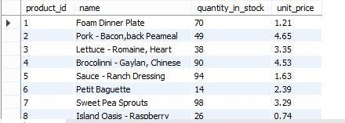

Create table
CREATE TABLE products ( product_id INT PRIMARY KEY, name VARCHAR(100), quantity_in_stock INT, unit_price DECIMAL(6,2)
);

Insert values
INSERT INTO products (product_id, name, quantity_in_stock, unit_price) VALUES
(1, 'Foam Dinner Plate', 70, 1.21),
(2, 'Pork - Bacon,back Peameal', 49, 4.65),
(3, 'Lettuce - Romaine, Heart', 38, 3.35),
(4, 'Brocolinni - Gaylan, Chinese', 90, 4.53),
(5, 'Sauce - Ranch Dressing', 94, 1.63),
(6, 'Petit Baguette', 14, 2.39),
(7, 'Sweet Pea Sprouts', 98, 3.29),
(8, 'Island Oasis - Rasoberry', 26, 0.74);

Now, let us implement the following SQL subquery with SELECT statement.
SELECT *
FROM products
WHERE product_id IN (
SELECT product_id
FROM products
WHERE quantity_in_stock > 45
);
This will produce the following result.
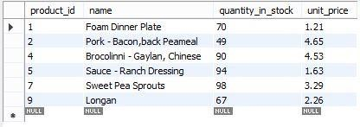

Subqueries With an INSERT statement
Consider the table ‘products_bkp’ with a similar structure to the ‘products’ table.
CREATE TABLE products_bkp AS
SELECT *
FROM products
WHERE 1=0;
Now, to copy the complete ‘products’ table into the ‘products_bkp’ table, you can use the SQL subquery with INSERT statement in the following way.
INSERT INTO products_bkp
SELECT *
FROM products
WHERE product_id IN (
SELECT product_id
FROM products
);
This will copy the data into the ‘products_bkp’ table.
INSERT INTO products_bkp
SELECT *
FROM products
WHERE product_id IN (
-- put your list of product_id values here
101, 102, 103, 104, 105, 106, 107, 108, 109, 110
);

Subqueries With an UPDATE Statement
You can set a new column value in an UPDATE statement equal to the result returned by a single row subquery.
Example:
If you want to update the unit price of products_bkp table where the unit price will be greater than the minimum unit price from the products table, we can use the following SQL query:
UPDATE products_bkp
SET unit_price = 5
WHERE unit_price > (
SELECT MIN(unit_price)
FROM products
);

This will produce the following result.
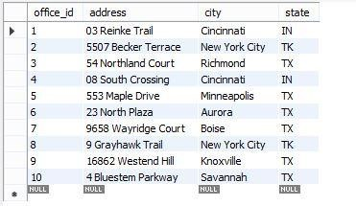

Subqueries With the DELETE Statement
We can use the DELETE statement with subqueries to delete the records.
Example:
The following SQL query will delete the data from the products_bkp table where the unit price is less than the maximum unit price from the table products.
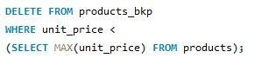
This will produce the following result.
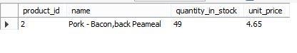
Result
Thus Sub Query in SQL was executed sucessfully
PROCEDURES

SQL>set server output on;
SQL>create table ar(eno number(10) primary key , ename varchar(10),exp number(10),sal number(10);

Table created.

SQL>insert into ar values(10,’hema’,12,30000);

1 row created.

SQL>insert into ar values(11,’kin’,6,22000);

1 row created.

Example 1:

Procedure using IN parameter

SQL>create or replace procedure pro(ex in number)is sala number(10);
2 begin
3 select sal into sala from ar where exp=ex;
4 if sala>10000 then
5 update ar set sal=sal*0.5 where exp=ex;
6 else
7 update ar set sal=sal*1.5 where exp=ex;
8 end if;
9 dbms_output.put_line(‘table updated’);
10 end;
11 /

Procedure created.

SQL>exec pro(6);
Table updated.
PL/SQL procedure successfully completed.
SQL>select * from ar;
ENO ENAME EXP SAL
----- ----------- -------- ------
10 hema 12 30000
11 kin 6 50000

Example 2:

Procedure using OUT parameter

SQL>create or replace procedure pro1(b out number)is
2 begin
3 select eno into b from ar where exp=6;
4 end;
5 /

Procedure created.

SQL>declare
2 b number;
3 name varchar(10);
4 begin
5 pro1(b);
6 dbms_output.put_line(b);
7 select ename into name from ar where eno=b;
8 dbms_ output.put_line(name);
9 end;
10 /

Output:
11
Kin

PL/SQL procedure successfully completed.

FUNCTIONS

Example 1:

Create a function to find the factorial of the given numbers:

SQL>create or replace function fac(n number)return number is
2 i number;
3 f number;
4 begin
5 i:=1;
6 f:=1;
7 loop
8 f:=f*i;
9 i:=i+1;
10 exit when i>n;
11 end loop;
12 return f;
13 end;
14 /

SQL>declare
2 r number;
3 begin
4 r:=fac(5);
5 dbms_output.put_line(‘THE FACTORIAL OF THE GIVEN NUMBER IS’||r);
6 end;
7 /

Output:

THE FACTORIAL OF THE GIVEN NUMBER IS 120.

Example 2:
SQL>create or replace function fn(id number) return number is
2 amt number;
3 begin
4 select sal into amt from emp where empno=id;
5 return amt;
6 end;
7 /
SQL> set server output on
SQL>declare
2 n number;
3 begin
4 n=fn(101);
5 dbms_output.put_line(‘sal’||n);
6 end;
7 /
Output:
1000

PL/SQL procedure successfully completed.

